S.A. COLLEGE OF ARTS AND SCIENCE
DEPARTMENT OF B.Sc. COMPUTER SCIENCE WITH ARTIFICIAL INTELLIGENCE
PROJECT DOCUMENTATION
BLOGNEST API
AI-POWERED BLOG CONTENT MANAGEMENT SYSTEM

PROJECT GUIDE | TEAM
Bursu Madhu | Mahesh Kumar D (Captain)  Keshore Kumar AK  Sharath Chandar A  Sakthivel  Aakash Aadithya V  TEAM ID: SWTID-2026-7372

1. ABSTRACT
ContentGen is a secure, modular REST API platform for blog creation, content management and AI-assisted writing. It is built with Node.js and Express.js, uses MongoDB with Mongoose for data management, and integrates Google Gemini AI for intelligent content generation and summarization.
The system combines traditional blogging functions with Generative AI to provide a faster and more personalized content creation workflow. JWT authentication, role-based access control, password hashing, validation, sanitization, rate limiting and structured logging are included as core backend controls.
2. PROBLEM STATEMENT
- Managing multiple drafts, categories and tags is time-consuming.
- Content approval and comment moderation require a centralized workflow.
- Media paths and metadata need organized management.
- Different users require different permissions.
- Creating and summarizing long-form content manually takes additional effort.
3. PROPOSED SOLUTION
BlogNest/ContentGen provides a centralized backend API that separates application business logic from frontend delivery. Permission-controlled services manage content scheduling, category taxonomy, media registration, user roles, comments and AI-assisted content operations.
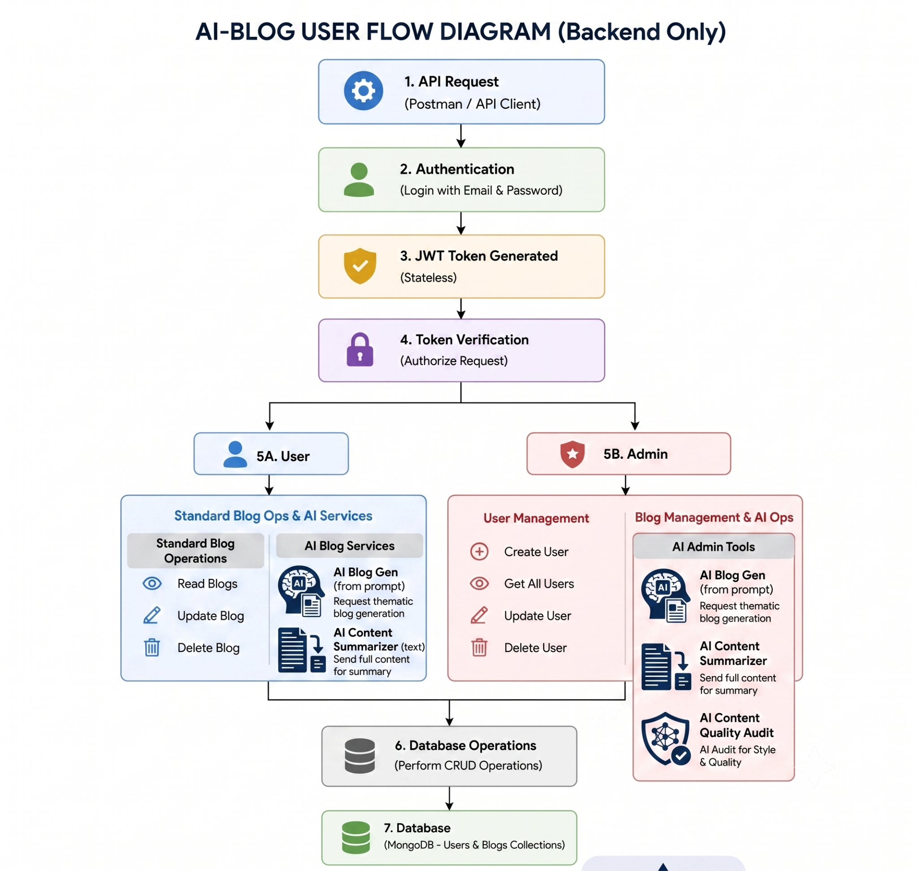

4. SOFTWARE REQUIREMENTS
Component | Requirement
Operating System | Windows 10/11, macOS or Linux
Node.js | Version 16 or above
npm | Version 8 or above
Express.js | REST API and routing framework
MongoDB | NoSQL database for users, posts, categories, comments and analytics
Mongoose | ODM for schema definition, validation and database interaction
Postman | API testing and verification
Code Editor | Visual Studio Code or similar IDE
5. HARDWARE REQUIREMENTS
- Processor: Intel Core i5 (8th Gen or above) / AMD Ryzen 5 or equivalent.
- RAM: 8 GB minimum; 16 GB recommended for concurrent services.
- Storage: At least 1 GB available project workspace.
6. KEY FEATURES
- JWT-based authentication and role-based route guarding.
- CRUD operations for blog content.
- Categories and tags for content organization.
- Comment moderation with approved, pending and spam states.
- Input sanitization and validation against common web vulnerabilities.
- AI-powered blog generation and intelligent summarization.
- Centralized error handling and structured logging.

7. PROJECT ARCHITECTURE
The application follows a layered server architecture. Incoming API requests pass through security and validation middleware before reaching controllers, services and the database layer.
- Interface: Postman or other API clients send HTTP requests and receive JSON responses.
- Express Server Gateway: Handles GET, POST, PUT and DELETE routes, JSON parsing and CORS.
- Authentication & Role Middleware: Validates JWT tokens and checks authorization thresholds.
- Granular Services: Applies business rules for drafts, approval, scheduling, publishing and comments.
- Database Interface: Mongoose translates application operations into MongoDB queries.
- AI Flow: Connects AI endpoints for blog generation and summarization.
8. MVC ARCHITECTURE
The backend separates responsibilities using the MVC pattern. The Model layer defines Mongoose schemas and data rules. The Controller layer validates requests, invokes business logic and returns JSON responses. Since this is a headless backend, the View layer is represented by the API routing interface rather than HTML templates.


9. DATABASE DESIGN

The main data entities are User, Post and Comment. A User can create multiple posts and comments. A Post can contain multiple comments. User passwords are stored as hashes and each user has a role used for authorization.
10. CORE ENTITIES
- User: _id, name, email, hashed password and role.
- Post: _id, userID, title/name, photo path, message/content, likes and timestamps.
- Comment: User-linked responses associated with individual posts.
11. USER ROLES
Role | Responsibility
Admin | Full environment control, user management, role assignment, comment cleanup and log inspection.
Editor | Reviews pending posts, manages publication workflow and category cleanup.
Author | Creates posts associated with the author's account.
Reader | Reads published content and posts comments.

12. PROJECT SETUP
- Create the project folder and open it in Visual Studio Code.
- Create the Server folder for the backend.
- Initialize the Node.js project using npm init -y.
- Create server.js and organize models, controllers and routes folders.
- Install required dependencies such as Express and Mongoose.
- Configure the MongoDB connection before performing database operations.

13. BACKEND DEVELOPMENT
The server exposes REST endpoints through Express.js. Controllers process requests and interact with Mongoose models. Routes are protected where required by authentication and role middleware.


14. DATABASE CONFIGURATION
MongoDB is used as the primary database. Mongoose provides schema definitions, validation and database interaction. The database connection is established before backend operations are executed.


15. API TESTING
Postman or the Thunder Client extension can be used to start and verify the backend API. The project documentation demonstrates registration, login, blog creation, blog retrieval, AI blog generation and blog summarization.

16. USER REGISTRATION & LOGIN


17. BLOG OPERATIONS



18. AI FEATURES
The AI layer provides automated blog generation and content summarization. The documented endpoints include /api/ai/generate-blog and /api/ai/summarize, allowing controllers to delegate text-processing tasks to an external AI model.

19. SECURITY
- JWT tokens provide stateless authentication.
- Role-based access control protects administrative and editorial routes.
- bcrypt.js is used for secure password hashing.
- Request validation and input sanitization reduce malformed and unsafe input.
- Rate limiting and structured logging support reliability and monitoring.
20. CONCLUSION
ContentGen demonstrates a modern AI-assisted backend for blog management. Its modular Express.js architecture, MongoDB data layer, role-based security and Gemini-powered AI services provide a structured foundation for content creation, management and intelligent text processing.

CODE FILES : https://drive.google.com/drive/folders/1j-34T_xqh6pqKTkX7w3JcHsEBRfWuCyQ?usp=sharing
DEMO VIDEO : https://drive.google.com/file/d/18e7h9QHe5v0BypPBV1-UfhGM8hXsIgIF/view?usp=sharing
API TESTING : https://drive.google.com/file/d/1vxNcLHAqvFxc4AWnqCxh-tzxcNcrRFzv/view?usp=sharing

PROJECT TEAM
Mahesh Kumar D — Captain | Keshore Kumar AK | Sharath Chandar A | Sakthivel | Aakash Aadithya V

